# Workshop Summary – Client Office

19th and 20th April, 2018, Connection One building.

# Agenda

Day 1 - 19th Apr

* Morning: Manpower cont’d, Integration Platform (9-10am, Cliff available), Safety Feedback
* Afternoon: Integration Platform, Drone

Day 2 - 20th Apr

* Morning: Site visit and meeting with RTO (if time permits)
* Afternoon: CMIC (2pm-3pm), CCTV (3pm-4pm) and Novade (4:30pm – 5pm)
* Wrap up: Summary of all findings

# DAY 1

## Business Overview

**Coastal Engineering Overview**

JSC have created world-class ports and sustainable coastal environments, sculpting shorelines and enhancing land values. JSC develops infrastructure for port & marine infrastructure (e.g., warehousing & berthing facilities for lighters and coastal vessels), develops shore protection structures, reclamation to raise land from sea.

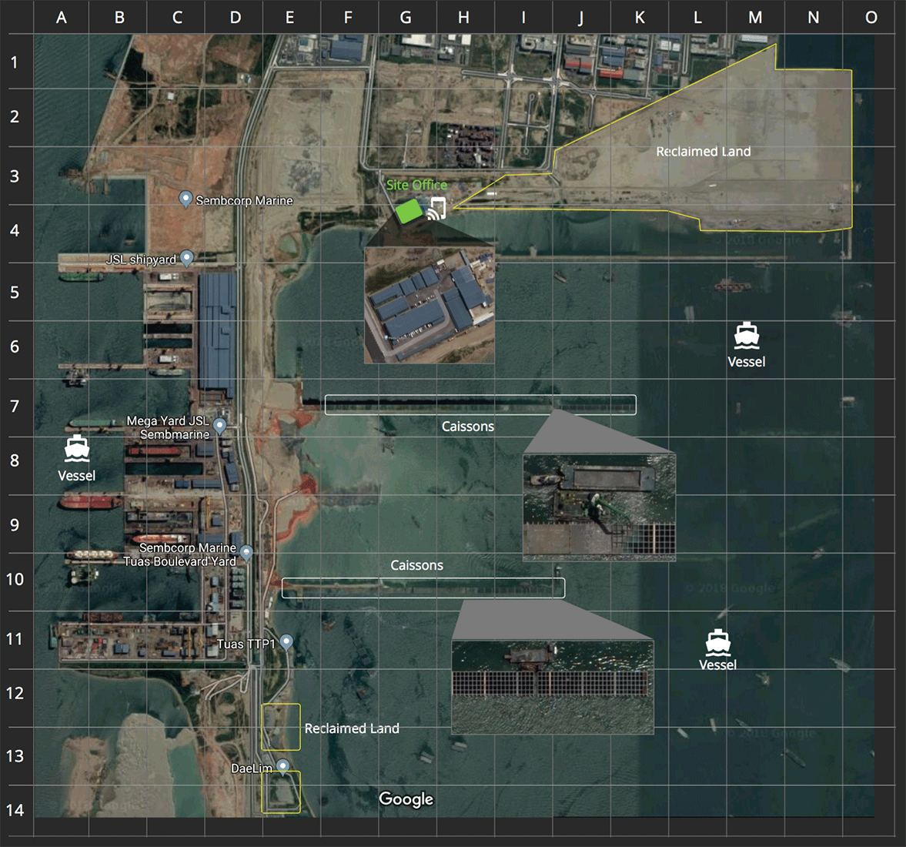

Figure 1. Layout Plan

**Priority has been discussed** (from high to low)

* Safety Feedback: this is top priority by SJ’s client.
* Novade (inspection, work) and Integration Platform
* Drone and CCTV
* Manpower: as this is more about administration.
* And, so on

**SJ Timeline**

* By June 2018: there must have ‘something’ started
* SJ Workshops next week with client: if next week (Wed, 25-Apr) Nash Tech can provide the milestone plan based on the outcome of 19th-20th workshop? So that SJ can discuss with Client.

**Design Principles**

* Abstraction of the data integrated among the systems within the Integration Platform. That means whatever the system is such as CMIC (not yet confirmed to use) to be interfaced, it must be easy to “plug” the system into the platform. Everything must be abstracted.
* Multi-tenancy is a must. First tenant will be JTC (SJ’s client), further tenants will be more clients, so it enables solution as a service. The key platform will be data for benchmarking services.
* Must maximise the use / re-use of existing framework (developed by Nash Tech) such as user authentication.

**UI & UX**

* Re-use the existing Audiance

**Governance**

* Product Owner: Wei Choo
* Product Advisor: El Salam
* Technical Advisor: Khiok Eng (until there is a replacement)
* Product Director: Lam Wei

**Others**

* Should have another name for “Smart Site Platform”, e.g., digital transformation services

## Safety Feedback

*(a system to define safety checklist, incident reporting, and safety feedback)*

Various activites can occur on site and safety is always of the utmost priority. There needs to be a way to keep track of good safety practices and alert on bad safety practices on site. This is about a check process of safety issues under [WSH](http://www.mom.gov.sg/workplace-safety-and-health) regulations.

Running a quick demo to SJ the existing Audiance system, we then can see some major differences.

**Audiance vs. Safety Feedback**

|  |  |
| --- | --- |
| Audiance | Safety Feedback |
| A location-based system to manage inspections done by auditors so that non-compliance defects can be managed properly. | A system for:   * incident reporting (which already happen) * to manage safety checklists and good & bad safety feedback (which has no incident) based on the regular safety checklists which are pre-defined from templates. |
| This is to do inspection of the project work.  It must link to a physical location. | This is safety and health check for workers who work at construction sites.  It doesn’t link to a physical site. |
| Defects are accurately located in an indoor specific area of a specified room in a building. | Issues (incident, feedback) are approximately located by GIS coordinates in the reclamed construction sites, e.g., captured from Google Maps, which are +/- 5 to 10 metres. |
| Eligible users can manage and maintain projects and their details. | Projects (and their details) are retrieved / imported from project factsheet (which is Excel-based file). Users can only view them, cannot change the details. |

3 key modules of Safety Feedback System.

* Safety inspection checklist / template
* Incident reporting
* Safety feedback

### **Safety Inspection**

#### Data Setup

* Project factsheet
* Project members (e.g., staff ID, name, email, etc): to be populated from master overview of User.

#### Maintain Safety Templates

Some steps have been discussed:

* JSC Admin to maintain
* Flexible to create / maintain templates ~~(Note: those being used will not be amended)~~
* Types of template including: Marine, Land, Caisson, or Others. For example, housekeeping may have an item saying “if the oil tanks have proper caps”.
* Ability to import from Excel-based files
* Admin users can upload and maintain, until he’s happy with the template, he will submit (or release) the template. It now becomes safety checklist ready for use.
* Checklist items in the template have points or weighting (for future use). Note: Point system is being used elsewhere by JSC. Weighting will be introduced at a later stage. For now, we just rely on points. This means that the summary will also include the points.
* Checklist items have two options only, Passed or Failed.
* No approval workflow of the template, admin does it manually (outside of the system)

Note: JSC will provide templates for reference.

#### Checklist Assignment

The process follows the flow in “JSC Coastal Engineering, Workflow Proposal.xlsx” and the flowchart to be provided by JSC.

Generally speaking, it has following steps:

* PM or SRE will pick up a checklist (from a list of checklists created from templates). Note that Marine / Land / Caission appointed by SRE, and Others appointed by RE.
* They will then assign the checklist for an employee (RTO). Every assignment needs indicate when to complete the inspection (i.e., deadline). Alert / notification sends to the RTO.
* The assignment (checklist to be assigned to an employee) will be handled regularly – weekly or monthly.
* When it closes to deadline (e.g., 2 hours – configurable) and the inspection has not started (means no check item is performed), there will have reminder sending to the RTO.
* When it reaches to the deadline and there still have no item performed, the SRE will do the inspection.

#### Summary Chart(s)

During the safety inspection of a project, for a specific check item, there will multiple times of inspection (by week, by month). For example, week 1 – Passed, week 2 – Failed, week 3 – Passed, and so on.

It requires to have a summary chart so that users can see the percentage of completion of inspection checklists for all projects.

* X-axis: the check items.
* Y-axis: the percentage of completion

Note: in future development, it can separate into various charts, each chart is for a project.

### **Incident Reporting**

#### Incident Logging

The process follows the flow in “JSC Coastal Engineering, Workflow Proposal.xlsx” and the flowchart to be provided by JSC. This is done on an ad-hoc basis when an incident happens.

* Whenever there is any incident happened in the construction sites, the **contractor** will trigger the issue.
* The issue must indicate what project the **contractor** is in, photo(s) captured for the incident, GIS location where the incident occurs.
* There are several types of issue: Onshore (L – land), Offshore (M – marine), UXO (unexploded ordnance), or Client Reporting.
* There also have Emergency contact (day time and night time) to call for ambulance when necessary.

Note: JSC to provide the detail information of the incident, and the category such as Near Miss, Accidents, etc.

#### Summary Chart(s)

It needs to provide a chart of incidents happened, grouped by their category.

The report is for SJ users and some are visible to Client.

### **Feedback Logging**

#### Feedback Logging

The process follows the flow in “JSC Coastal Engineering, Workflow Proposal.xlsx” and the flowchart to be provided by JSC. This is done on an ad-hoc basis when the

* Whenever there is any feedback or observation raised in the construction sites, the RTO will trigger the log.
* The log must indicate what project the RTO is in, photo(s) captured for the feedback or observation, GIS location where the feedback is captured, and some remarks or comments.
* There are several types of log: by type (Good or Bad), by severity, and by their category.
* There is no possibility when the inspection is done partially, i.e., done partially in one day and the remaining items in another day. All must be completed by the timeline with Passed / Failed results. For the failed items, there must attach photo(s) and give comment.

Note: JSC to provide the detail information of the feedback log, and the category.

#### Summary Chart(s)

It needs to provide a chart of logs captured, grouped by type, severity, and category.

The report is open for anyone to view.

## Drone & CCTV – Integration Platform

*(Photo/Video management and layout dashboard)*

There are two options for the approach:

* **Option 1** (preferable): utilising a cloud-based photo management tool to stored the photos & videos captured from drone and CCTV devices. These are organized in a proper naming structure so that they can be picked up (by the system) when viewing in the layout plan / dashboard. See Figure 5. How Drone & CCTV Dashboard Works for more reference.
* **Option 2**: utilising the 3rd pzxarty drone mapping software, see below, for progress tracking, 3D modelling, surveying & monitoring, and inspection. In such software, the drone device can fly by the programmed journey. By using the 3rd party, it is then integrated to Dashboard system for viewing various types of dashboard / reporting.

Note: there are several mapping softwares for consideration:

* Pix4D Capture
* Drone Deploy
* Agisoft
* DJI

It requires to provide a layout plan / dashboard as the representation of the site via photos & videos. The representation enables:

* Admin: to upload photos when necessary, to layout the photo / video files, and submit
* Client: to view the master layout, and open up a series of photos to see progress of work

Users must be restricted the functions (e.g., Download).

### **Setup Data**

Users are able to define & maintain the coordinates of:

* Spots in a layout plan grid and
* Spots (identified by icons) in the predefined / programmed journey of drone device.
* Spots of the stationary CCTV devices
* Pre-defined spots of the movable CCTV devices.

Note: data grid is predefined elsewhere in the system.

### **Photo Management**

This must be a cloud-based repository which enables users to upload the photos & videos from drone and CCTV devices.

In the photo / video, there must include their coordinates information.

Photo & video files must be arranged in a sequence (e.g, by date time captured, by grid, by project, by device captured), so that it enables the progess of work when viewing by sequence of time.

### **Dashboard**

To build up a dashboard of layout plan with the coordinates set up above. Users can click on spots to see details of photos / videos – retrieved from cloud-based repository – by using the matched coordinates.

Note: How to do the scaling so that the layout plan drawing can fit to the desktop screen?

# DAY 2

## System Overview

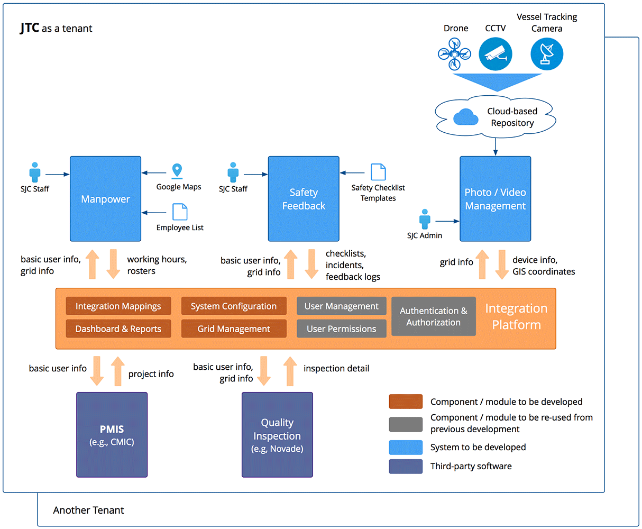

Figure 2. Integration System Overview

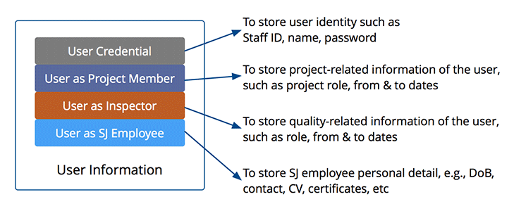

Figure 3. User Information Detail

Users are essentially managed in the platform:

* Users can be SJ staff or non-SJ staff such as Client, Contractor, Stakeholders
* All user credentials are maintained in the Identity module.
* In every system (e.g., PMIS, Novade, Manpower), the users are presented with relevant information.

## Manpower & Inspection (Novade) at Site

### **PMIS vs. Novade vs. Manpower**

Responsibilities of business users when working in various systems are shown below.

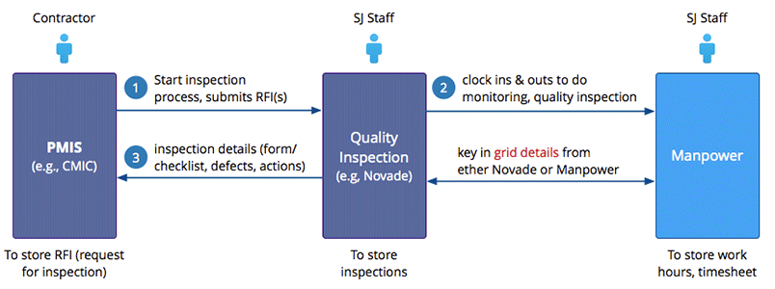

Figure 3. PMIS vs. Novade vs. Manpower

PMIS to kick start the inspection process by submission of RFI (request for information) to relevant stakeholders, it then sends out or pushes notification / email to SRTO / SRE saying that work inspection for sandkey areas needs to be conducted. SRTO then will take the inspection template(s), use the Novade mobile app, go to the site, and perform various checks (e.g., if the Contractor builds to the agreed standards, if the materials are correct). Getting to the site, he will require to clock in & out.

Once he is done the checklist, he will sign off and submit. SJ then will review to see if any change. The Contractor will then incorporate to the project. Sometimes the RTO spots something on site, he will inform the Contractor right there. In Novade, app SJ staff is able to assign the defects found to person-in-charge of the contractor, and there will have notification sending to that contractor person.

Note

* Utilise grid information instead of GIS coordinates in the construction sites
* In the Manpower, it doesn’t need to track the route coordinates of RE/RTO locations but spots in the grid, e.g., A1 – B1 – C3 – D5
* Using the GPS location tracking in employee’s mobile device may cause issues of their data plan.
* In the construction sites there may have areas which have weak / very week mobile coverage.

### **Work Hours & Timesheet**

See the calculations in Figure 6. Working Hours & Timesheet

At the time clock ins & outs at the site office, it needs to capture following information:

* Time
* Location (by GPS located, to capture coordinates)
* Require Approval: this will be used when the user clocks in at a place which is out side of the construction site.
* Remarks

If approval requires, the submission of this clock-in will send email notification of the logged user’s reporting officer. This notifies that the employee goes to work but not from the construction site (e.g., at training office)

## Vessel Tracking

Vessels are involved in marine operations of the dredging process. ~~There are a number of cameras around the area of SJ projects enable users to track the vessel movements.~~

* Only track vessels which are in the boundary of the project. They are not only project’s vessels but any vessel goes to the dredging area.
* Vessels are currently tracked and managed via [Echol Tech](http://www.echoltech.com/) software.

The vessel detail includes:

* ID & Name
* Time in & out
* Project
* Coordinates (within the boundary)

Note: it hasn’t been required to integrate vessel tracking module to Integration Platform yet.

## PMIS (CMiC) – Integration Platform

CMiC is a fully integrated construction software solution that supports the entire construction project lifecycle by offering a variety of features that help in project management, financial controls, budgeting and customer management.

As a construction software that can be deployed in public cloud, private cloud, and on-premise, CMiC provides four modules with each module offering sets of features. These modules are financials, project controls, asset management, and experience management. CMiC improves decision-making by providing users actual and forecasting perspectives in managing the resources of construction companies and businesses.

For integration with SJ’s platform, it will be 2-way communication between CMiC and IP, see Figure 2. Integration System Overview and Figure 3. User Information Detail

**From SJ platform to CMiC:**

* User basic information (e.g, Staff ID)

**From CMiC to SJ platform:**

* Project information: including project name, client name (e.g., JTC Corporation), type, project status, PM, location (e.g., Pandan Basin), period (e.g., February 2017 – July 2019)
* Support PUSH mechanism: any time the project information changes, it pushes the relevant changes to SJ platform.
* Project-related files such as drawings.

CMiC enables the integration with **API**.

**Next step:**

* Need to know the API specs, how to connect, how to extract
* Check if CMiC is able to receive & consolidate the user info and integrate back to its project management system.

## Novade Quality – Integration Platform

Novade Quality is an enterprise application to manage project quality from construction to handover. It’s a complete solution engaging all key stakeholders on the project. By using standard definitions and checklists, users can analyse data, identify trends, draw correlations and ultimately improve quality on projects while reducing costs.

For integration with SJ’s platform, it will be 2-way communication between Novade and IP, see Figure 2. Integration System Overview and Figure 3. User Information Detail

**From SJ platform to Novade:**

* User basic information (e.g, Staff ID)

**From Novade to SJ platform:**

* Inspection information: e.g., inspection activity checklist, defects, spots on the layout grid, corrective / follow-up actions

## Primavera

Not integrating at the current stage.

# SUPPORTING INFORMATION

**How Land Reclamation Works?**

The proposed site for reclamation is first investigated to determine seabed conditions, availability of fill materials as well as the shape and alignment of the reclaimed area. Environmental feasibility studies are then carried out to assess the impact on water quality, water level, tidal flow, sedimentation and marine life. Work proper begins with the erection of containment dykes (cement walls) made of sand and rock around the perimeter of the area to be reclaimed. Materials such as cut-hill soil, sand and clay are then transported from other sites to fill the enclosed area. The newly reclaimed land must be allowed to settle naturally over time before any structures can be built. In most cases, the process is speeded up with soil investigation and improvement methods.

Land reclamation is a part of the larger coastal engineering process which involves dredging operations. Dredging basically refers to the excavation activities that are usually carried out underwater to remove certain unwanted items from the bottom of shallow seas or fresh water. This is mainly done to ensure that the waterways are fully navigable.

In land reclamation, dredging is to mine sand, clay or rock from the seabed and using it to construct new land elsewhere. This is typically performed by a cutter-suction dredge or trailing suction hopper dredge.

The coastal engineers are responsible for conducting dredging operations to retain a secure route for the transportation of vessels into or away from waterways and harbours. The functions and responsibilities of coastal engineering are crucial to the protection of coastal environment and the operation of commercial shipping industry.

**Safety Feedback**

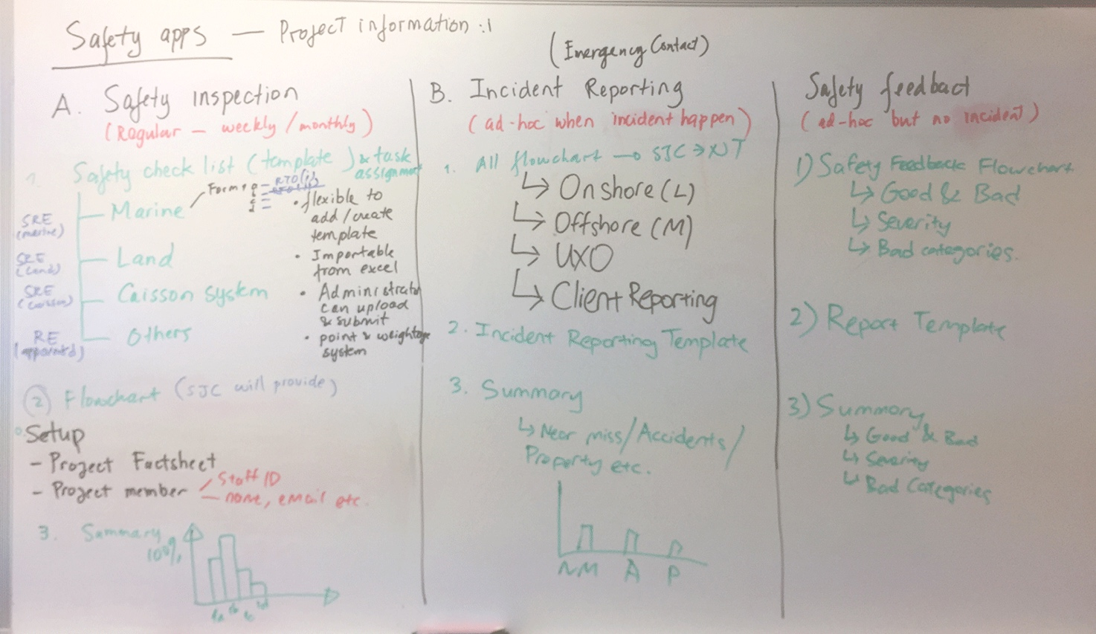

Figure 4. How Safety Feedback Works

**Drone & CCTV Dashboard**

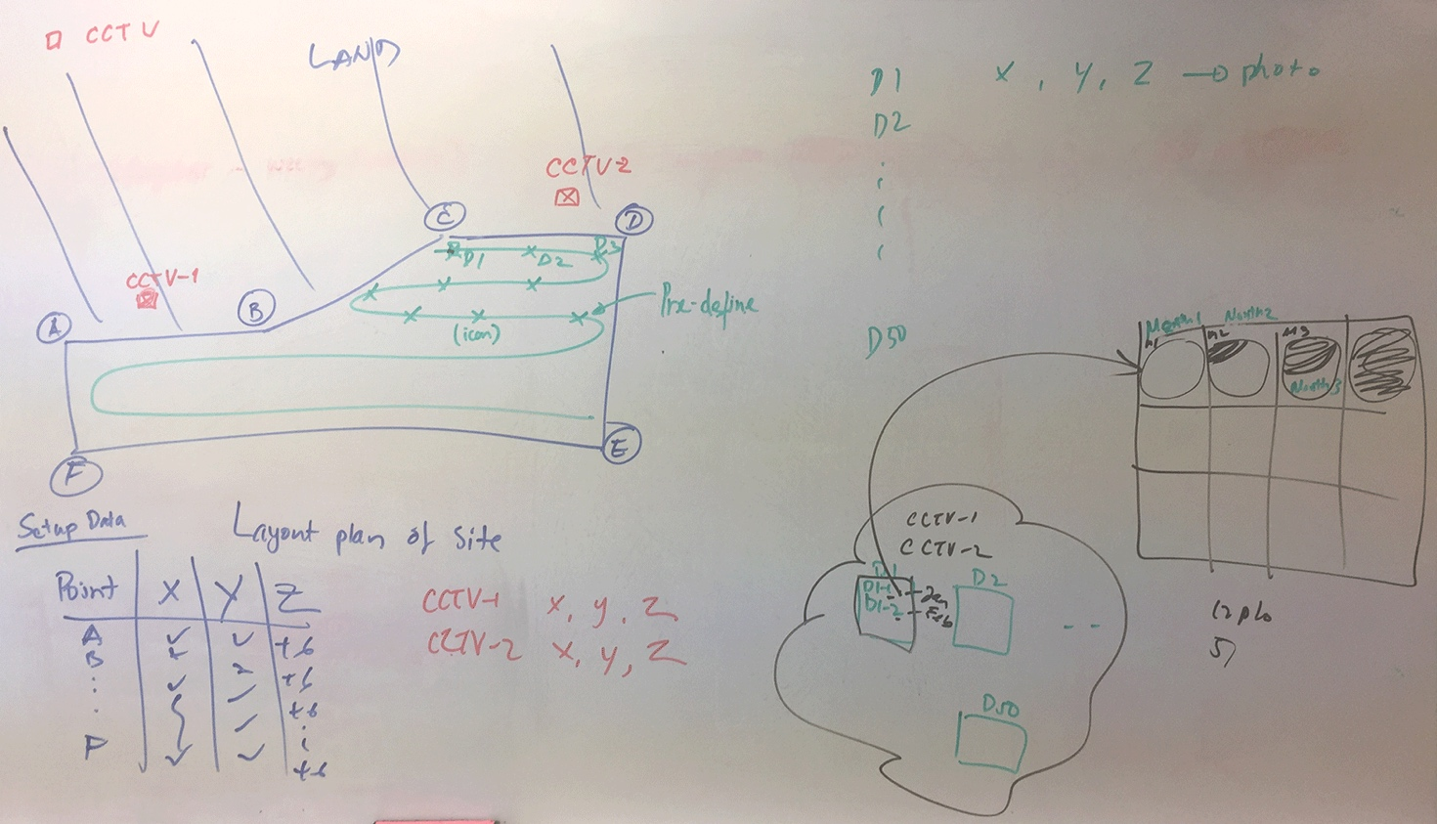

Figure 5. How Drone & CCTV Dashboard Works

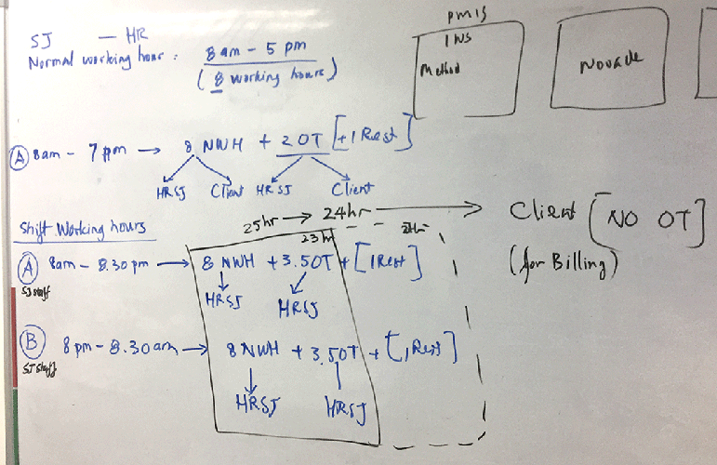

Figure 6. Working Hours & Timesheet

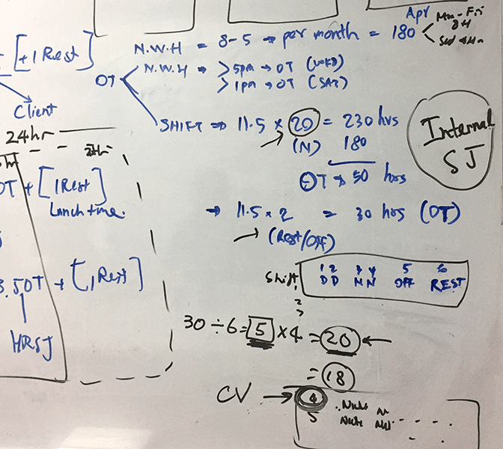

Figure 7. JSC Timesheet Calculation